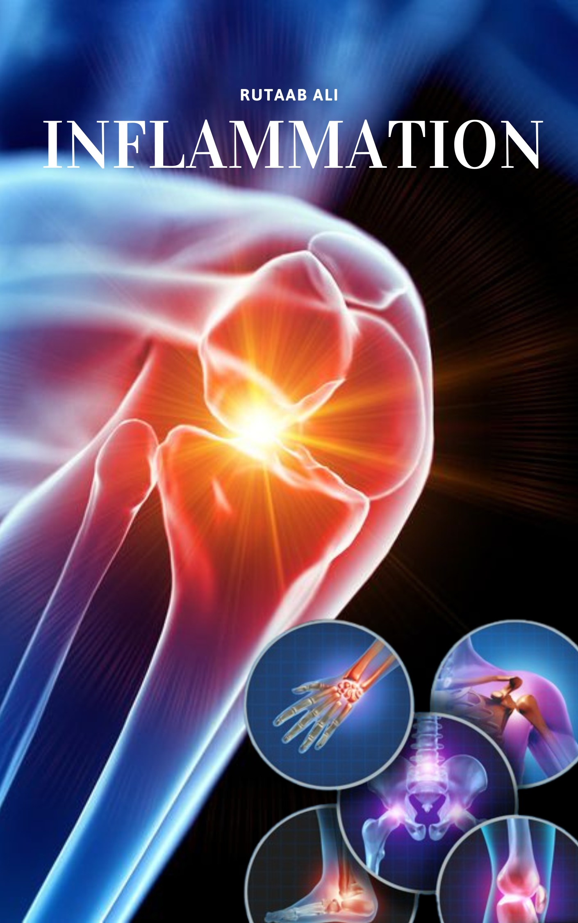

Inflammation and Tissue Repair

I. Overview of Inflammation:
Inflammation is a protective response of vascularized tissues to infections and tissue damage. It is crucial for survival, as it helps eliminate offending agents like microbes and toxins, as well as the consequences of injury, such as necrotic cells and tissues. Without inflammation, infections could spread unchecked, and wounds might not heal, potentially leading to persistent sores.

General Features of Inflammation
While often perceived as harmful, inflammation is a vital defense mechanism. It involves bringing cells and molecules of host defense, like phagocytic leukocytes, antibodies, and complement proteins, from the circulation to the sites where they are needed. Some inflammatory cells also reside in tissues, acting as sentinels.
Key Steps in an Inflammatory Reaction (The Five Rs):
- Recognition of the offending agent (e.g., microbes, toxins, necrotic cells) by host cells and molecules in extravascular tissues.
- Recruitment of leukocytes and plasma proteins from circulation to the site of injury.
- Removal of the offending substance through activation of leukocytes and proteins.
- Regulation and termination of the reaction.
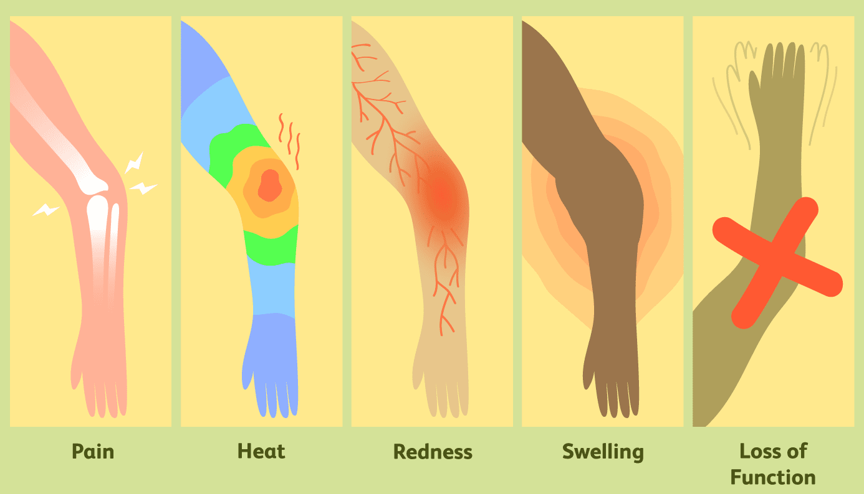
- Repair of the damaged tissue.
Cardinal Signs of Inflammation: These external manifestations were first described over 2000 years ago by Celsus, with Virchow adding the fifth:
- Heat (calor)
- Redness (rubor)
- Swelling (tumor)
- Pain (dolor)
- Loss of function (functio laesa)

Types of Inflammation:

Acute Inflammation:
  - Onset: "initial, rapid response... typically develops within minutes or hours."
  - Duration: "short duration, lasting for several hours or a few days."
  - Characteristics: "exudation of fluid and plasma proteins (edema) and the emigration of leukocytes, predominantly neutrophils."
  - Outcome: Aims to eliminate offenders and repair injury; if unsuccessful, may progress to chronic inflammation.

Chronic Inflammation:
  - Onset: "Slow: days"
  - Duration: "prolonged duration (weeks or months)."
  - Characteristics: "more tissue destruction, the presence of lymphocytes and macrophages, the proliferation of blood vessels, and fibrosis."
  - Outcome: Coexistence of inflammation, tissue injury, and repair attempts.

II. Causes of Inflammation
Inflammatory reactions are triggered by various stimuli:
Inflammatory reactions can be triggered by a variety of stimuli:
- Infections: Caused by bacteria, viruses, fungi, or parasites, and their microbial toxins. Different pathogens can produce varying inflammatory responses, from mild to severe or prolonged.
- Tissue Necrosis: Inflammation is triggered regardless of the cause of cell death, which can include ischemia (e.g., myocardial infarction), trauma, and physical or chemical injury (e.g., burns, frostbite, radiation, environmental chemicals). Molecules released from necrotic cells are known to trigger inflammation.
- Foreign Bodies: Substances like splinters, dirt, or sutures can elicit inflammation directly or by causing traumatic tissue injury or carrying microbes. Even large amounts of endogenous substances, such as urate crystals (in gout) and cholesterol crystals (in atherosclerosis), can stimulate inflammation.
- Immune Reactions (Hypersensitivity): These reactions involve the immune system damaging the body's own tissues. This can be directed against self-antigens (autoimmune diseases), harmless environmental substances (allergies), or microbes. Such reactions tend to be persistent and often involve chronic inflammation due to the inability to eliminate the stimulus.
III. Recognition of Microbes and Damaged Cells
The first step in inflammation is the recognition of microbes and necrotic cells by cellular receptors and circulating proteins.
- Cellular Receptors for Microbes: Phagocytes, dendritic cells, and other cells express receptors like Toll-like receptors (TLRs), which detect infectious pathogens by recognizing common microbial motifs (pathogen-associated molecular patterns, or PAMPs). This stimulates the production of cytokines that induce inflammation and proteins that promote lymphocyte activation.
- Sensors of Cell Damage: All cells have cytosolic receptors that recognize damage-associated molecular patterns (DAMPs), molecules released or altered due to cell damage. Examples include uric acid, ATP, reduced intracellular K+, and cytoplasmic DNA. These receptors activate the inflammasome, a multiprotein cytosolic complex that induces the production of interleukin-1 (IL-1), which recruits leukocytes and triggers inflammation. The inflammasome has been linked to inflammatory reactions in conditions like gout, atherosclerosis, type 2 diabetes, and Alzheimer disease.
- Circulating Proteins: Plasma proteins like the complement system and mannose-binding lectin recognize blood-borne microbes, functioning to destroy them and stimulate inflammation at infection sites.

IV. Acute Inflammation
Acute inflammation is the initial, rapid response to infections and tissue damage.
- Onset: Typically develops within minutes or hours.
- Duration: Short-lived, lasting from several hours to a few days.
- Main Characteristics: Marked by the exudation of fluid and plasma proteins (edema) and the emigration of leukocytes, predominantly neutrophils (polymorphonuclear leukocytes).
- Outcome: If the offending agent is eliminated, the reaction subsides, and residual injury is repaired (resolution). However, if the stimulus persists, it can progress to chronic inflammation.
Acute inflammation involves three major components:
- Dilation of small vessels: Increases blood flow.
- Increased permeability of microvasculature: Allows plasma proteins and leukocytes to leave circulation.
- Emigration of leukocytes: Leukocytes accumulate and activate to eliminate the offending agent.

A. Vascular Reactions in Acute Inflammation
In acute inflammation, the vascular reactions are the body's protective response to infections and tissue damage. These reactions are designed to maximize the movement of plasma proteins and leukocytes from the circulation into the affected site to eliminate offending agents.
The vascular reactions of acute inflammation involve three major components:
- Dilation of small vessels, leading to an increase in blood flow.
- Increased permeability of the microvasculature, enabling plasma proteins and leukocytes to leave the circulation.
- Emigration of leukocytes from the microcirculation, their accumulation at the injury site, and their activation.

Changes in Vascular Flow and Caliber
The vascular reactions begin early after injury with specific changes in blood flow and vessel diameter:
- Vasodilation is one of the earliest manifestations of acute inflammation, sometimes preceded by transient vasoconstriction. This dilation is induced by various mediators, notably histamine, acting on vascular smooth muscle. Vasodilation first affects arterioles and then opens new capillary beds, resulting in increased blood flow which causes the characteristic heat and redness at the inflammation site.
- This vasodilation is quickly followed by an increased permeability of the microvasculature, leading to the outpouring of protein-rich fluid, known as an exudate, into the extravascular tissues.
- The loss of fluid from the vessels and the increased vessel diameter cause the blood flow to slow down, leading to a concentration of red cells and increased blood viscosity. This results in stasis of blood flow, where small vessels become engorged with slowly moving red cells, seen as vascular congestion and externally as localized redness.
- As stasis develops, blood leukocytes, primarily neutrophils, accumulate along the vascular endothelium. Simultaneously, endothelial cells are activated by local mediators (such as cytokines) to express increased levels of adhesion molecules. Leukocytes then adhere to the endothelium and subsequently migrate through the vessel wall into the interstitial tissue.

Increased Vascular Permeability (Vascular Leakage)
Increased vascular permeability is crucial for allowing plasma proteins and leukocytes, which are mediators of host defense, to enter the sites of infection or tissue damage.
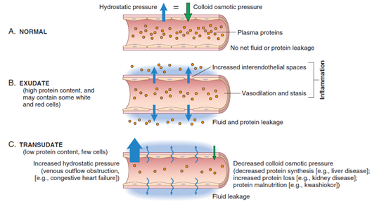
- The escape of fluid, proteins, and blood cells from the vascular system into interstitial tissues or body cavities is known as exudation. An exudate is characterized by a high protein concentration and contains cellular debris, indicating increased permeability during an inflammatory reaction. In contrast, a transudate is a fluid with low protein content, little or no cellular material, and low specific gravity, typically formed due to osmotic or hydrostatic imbalance across vessels with normal permeability.
Edema refers to an excess of fluid in the interstitial tissue or serous cavities, which can be either an exudate or a transudate. If the exudate is rich in leukocytes (mostly neutrophils), dead cell debris, and often microbes, it is termed pus or a purulent exudate.
Several mechanisms contribute to increased vascular permeability in acute inflammation:
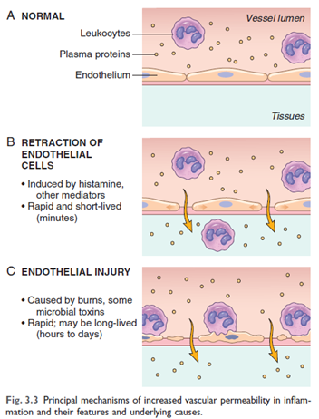
- Retraction of endothelial cells, creating openings in interendothelial spaces, is the most common mechanism of vascular leakage. This is rapidly produced by chemical mediators such as histamine, bradykinin, and leukotrienes. This "immediate transient response" typically occurs within 15 to 30 minutes and is short-lived, primarily affecting postcapillary venules.
- Endothelial injury can result from direct damage to the endothelium (e.g., severe burns, microbial toxins) or be induced by adhering neutrophils. Leakage often starts immediately after injury and can be sustained for several hours until damaged vessels are thrombosed or repaired.
- Increased transport of fluids and proteins through the endothelial cells (transcytosis) may also occur, potentially involving intracellular channels that open in response to factors like vascular endothelial growth factor (VEGF). However, its precise contribution to vascular permeability in human acute inflammation is not fully clear.

Responses of Lymphatic Vessels and Lymph Nodes
Lymphatic vessels and lymph nodes act as filters for extravascular fluids.
- During inflammation, lymph flow increases to help drain the accumulating edema fluid caused by increased vascular permeability.
- In addition to fluid, leukocytes, cellular debris, and microbes can enter the lymphatics.
- Sometimes, the lymphatic vessels can become secondarily inflamed (lymphangitis), and the draining lymph nodes may become enlarged due to increased cellularity (lymphadenitis). This cluster of changes is termed reactive or inflammatory lymphadenitis. The presence of red streaks near a skin wound can be a clinical sign of lymphangitis, often accompanied by painful enlargement of draining lymph nodes.

B. Leukocyte Recruitment to Sites of Inflammation
The journey of leukocytes from the bloodstream to the extravascular tissues is a multistep process mediated and controlled by adhesion molecules and cytokines. This sequence allows leukocytes, which normally flow rapidly in the blood, to be stopped, guided, and activated at the precise location of injury or infection.
The phases of leukocyte recruitment include:

Changes in Vascular Flow and Caliber (Vasodilation and Stasis):
- The process begins with vasodilation, primarily of arterioles, induced by mediators like histamine. This vasodilation leads to increased blood flow, which is responsible for the heat (calor) and redness (rubor) at the site of inflammation.
- Following vasodilation, there is a rapid increase in the permeability of the microvasculature, causing protein-rich fluid (exudate) to pour into the extravascular tissues.
- The loss of fluid and increased vessel diameter result in a slowing of blood flow and an increase in blood viscosity, leading to stasis. During stasis, red cells become concentrated, and small vessels become engorged, appearing histologically as vascular congestion and externally as localized redness.
- As stasis develops, blood leukocytes, mainly neutrophils, begin to accumulate along the vascular endothelium. This process, where leukocytes redistribute from the central axial column to a peripheral position along the endothelial surface, is called margination.

Leukocyte Adhesion to Endothelium:
- Rolling: Once leukocytes are marginalized, they engage in initial, weak interactions with the endothelial cells. This "rolling" is mediated by a family of receptors called selectins (E-selectin, P-selectin, L-selectin). These interactions are of low affinity and easily disrupted by blood flow, causing the leukocytes to bind, detach, and re-bind, tumbling along the endothelial surface.
  - Endothelial selectins (E-selectin and P-selectin) are typically expressed at low levels or not at all on unactivated endothelium but are upregulated by inflammatory cytokines such as TNF (Tumor Necrosis Factor) and IL-1 (Interleukin-1), and mediators like histamine and thrombin. This upregulation restricts leukocyte binding to the sites of inflammation.
  - L-selectin is expressed on most leukocytes and binds to ligands on endothelial cells.
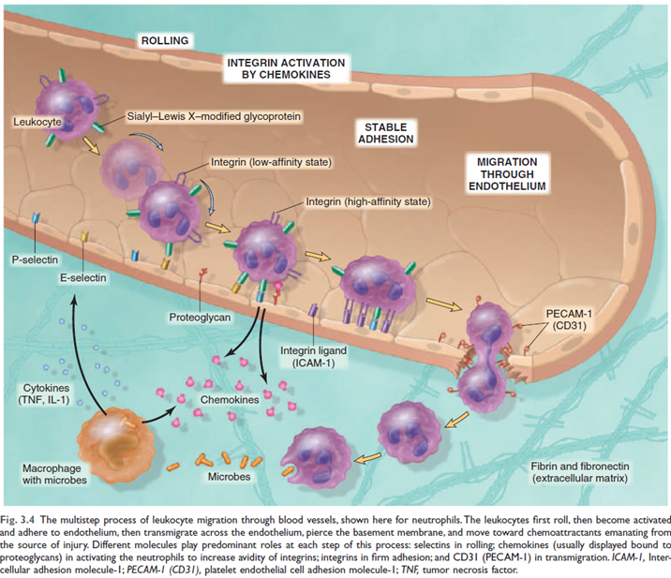

Firm Adhesion:
The rolling interactions allow leukocytes to detect and react to further changes on the endothelium. Chemokines, chemoattractant cytokines secreted by cells at the inflammation site, bind to endothelial cell proteoglycans and are displayed at high concentrations on the endothelial surface.
  - When rolling leukocytes encounter these displayed chemokines, they become activated, leading to a conformational change and clustering of their integrins (transmembrane glycoproteins like LFA-1, MAC-1, and VLA-4) on the leukocyte surface, converting them to a high-affinity state.
  - Simultaneously, cytokines like TNF and IL-1 activate endothelial cells to increase their expression of integrin ligands, such as ICAM-1 (Intercellular Adhesion Molecule-1): Binds to LFA-1 (Leukocyte Function–Associated Antigen-1) and Mac-1 (Macrophage-1 Antigen). VCAM-1 (Vascular Cell Adhesion Molecule-1): Interacts with VLA-4 (Very Late Antigen-4)..
  - The combination of increased integrin affinity on leukocytes and increased ligand expression on endothelium results in firm, integrin-mediated binding, causing leukocytes to stop rolling and firmly attach to the endothelium. Genetic deficiencies in these adhesion molecules can lead to impaired leukocyte adhesion and recurrent bacterial infections.
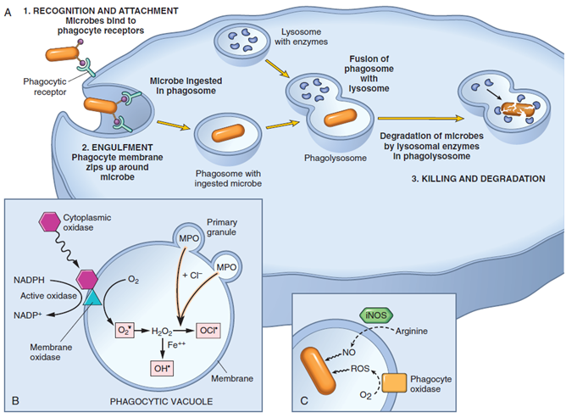
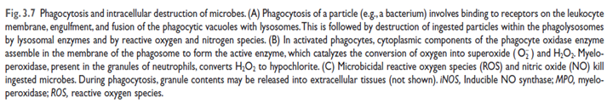

Leukocyte Migration through Endothelium (Transmigration or Diapedesis):
- After firm adhesion, leukocytes migrate through the vessel wall, primarily by squeezing between endothelial cells at intercellular junctions. This process mainly occurs in postcapillary venules, where endothelial cell retraction is maximal.
- Platelet endothelial cell adhesion molecule-1 (PECAM-1, also called CD31), an adhesion molecule expressed on both leukocytes and endothelial cells, mediates the binding events necessary for leukocytes to traverse the endothelium.
- After traversing the endothelium, leukocytes penetrate the basement membrane, likely by secreting collagenases, and enter the extravascular tissue, typically without injuring the vessel wall.

Chemotaxis of Leukocytes:
- Once in the tissues, leukocytes move towards the site of injury by chemotaxis, which is locomotion along a chemical gradient.
- Both exogenous (e.g., bacterial products, particularly N-formyl methionine-terminated peptides) and endogenous substances act as chemoattractants.
- Key endogenous chemoattractants include:
  - Cytokines, especially members of the chemokine family (e.g., IL-8 for neutrophils; MCP-1, eotaxin, MIP-1α for monocytes, eosinophils, basophils, and lymphocytes).
  - Components of the complement system, particularly C5a (and to a lesser extent C3a), which are also called anaphylatoxins and stimulate histamine release, increasing vascular permeability and causing vasodilation. C5a is a potent chemotactic agent for neutrophils, monocytes, eosinophils, and basophils, and activates the lipoxygenase pathway in these cells.
  - Products of the lipoxygenase pathway of arachidonic acid (AA) metabolism, particularly leukotriene B4 (LTB4).
  - These chemoattractants bind to G protein-coupled receptors on leukocytes, initiating signals that lead to actin polymerization and myosin filament localization, effectively pulling the cell in the direction of the stimulus.
  - Mechanism of Movement: These chemoattractants bind to G protein-coupled receptors on leukocyte surfaces, activating signaling pathways that rearrange the actin cytoskeleton. Actin polymerization concentrates at the leading edge, while myosin filaments localize at the rear, enabling the cell to move via filopodia extension. This motion pulls the leukocyte forward toward the source of chemoattractants.
- Nature of the Leukocyte Infiltrate: The type of leukocyte infiltrating the site of inflammation varies with the age of the response and the stimulus.
  - In most acute inflammation, neutrophils predominate during the first 6 to 24 hours. This is due to their higher numbers in blood, more rapid response to chemokines, and stronger initial attachment to adhesion molecules. Neutrophils are short-lived, undergoing apoptosis and disappearing within 24 to 48 hours after entering tissues.
  - Neutrophils are gradually replaced by monocyte-derived macrophages over 24 to 48 hours. Macrophages survive longer and can proliferate in tissues, becoming the dominant cell population in prolonged inflammatory reactions.
  - However, exceptions exist: prolonged neutrophilic infiltration in Pseudomonas infections; initial lymphocyte predominance in viral infections; activated lymphocytes, macrophages, and plasma cells in some hypersensitivity reactions; and eosinophils in allergic reactions.

C. Phagocytosis and Clearance of the Offending Agent
- Phagocytosis and the subsequent clearance of offending agents are crucial functions of the inflammatory response, particularly carried out by phagocytic leukocytes such as neutrophils and macrophages. This process involves the activation of these leukocytes, enabling them to destroy and eliminate harmful substances like microbes and necrotic cells.
- This is a tightly regulated process, ensuring that the body's defenders are activated only when required, preventing unnecessary energy expenditure.
Here are the sequential steps and mechanisms involved in phagocytosis and clearance:

I. Leukocyte Activation
After leukocytes, particularly neutrophils and monocytes, are recruited to a site of infection or tissue injury, they must be activated to perform their functions. This activation is induced by the recognition of microbes or dead cells.
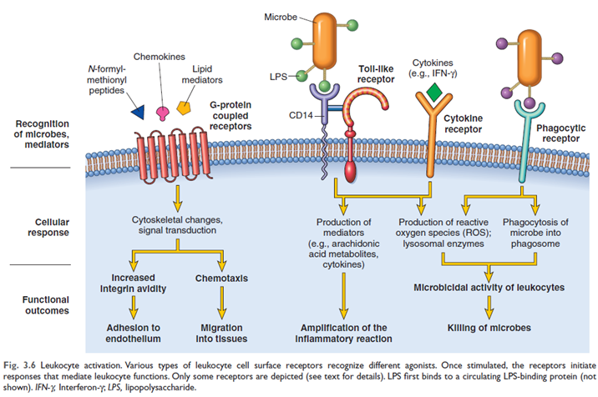

II. Phagocytosis
Phagocytosis itself involves three sequential steps:
1. Recognition and Attachment of the Particle
- This is the first step, where the particle to be ingested binds to the leukocyte.
- Phagocytes utilize various receptors to recognize and attach to microbes or damaged cells. These include:
  - Mannose receptors: These lectins bind to terminal mannose and fucose residues typically found on microbial cell walls, distinguishing them from host glycoproteins.
- Scavenger receptors: These bind and ingest low-density lipoprotein (LDL) particles and a variety of microbes.
- Receptors for opsonins: The efficiency of phagocytosis is significantly enhanced when microbes are opsonized (coated) by specific proteins called opsonins. Major opsonins include:
  - Immunoglobulin (Ig) G antibodies.
  - C3b breakdown product of complement activation.
  - Certain plasma lectins, such as mannose-binding lectin.
- Toll-like receptors (TLRs) and other microbial sensors recognize pathogen-associated molecular patterns (PAMPs) on microbes, stimulating production and expression of secreted and membrane proteins, including cytokines that induce inflammation.
2. Engulfment
- Once a particle is bound to phagocyte receptors, extensions of the cytoplasm, called pseudopods, flow around the particle.
- The plasma membrane then pinches off, forming a cytosolic vesicle called a phagosome, which encloses the particle.
- The phagosome subsequently fuses with lysosomes, discharging lysosomal contents into the newly formed phagolysosome.
3. Killing or Degradation of the Ingested Material
- This is the final step in the elimination of infectious agents and necrotic cells, primarily accomplished within the phagolysosome.
- The killing and degradation mechanisms are most efficient after the phagocytes are activated. These mechanisms include:
- Reactive Oxygen Species (ROS):
  - Also known as reactive oxygen intermediates, ROS are produced by the rapid assembly and activation of phagocyte oxidase (NADPH oxidase).
  - This enzyme oxidizes NADPH and reduces oxygen to the superoxide anion (O²⁻), a process tightly linked to phagocytosis in neutrophils, called the respiratory burst.
  - Superoxide is converted to hydrogen peroxide (H2O2), mostly by spontaneous dismutation (Superoxide dismutase).
  - Neutrophils' azurophilic granules contain myeloperoxidase (MPO), which, in the presence of a halide (e.g., Cl⁻), converts H₂O₂ to hypochlorite (OCl⁻), a potent antimicrobial agent. The H₂O₂-MPO-halide system is the most efficient bactericidal system of neutrophils.
  - H2O2 can also be converted to the highly destructive hydroxyl radical (OH•).
  - These oxygen-derived free radicals attack and damage lipids, proteins, and nucleic acids of microbes and host cells.
  - ROS can also be released extracellularly, potentially contributing to tissue damage during inflammation.
- Nitric Oxide (NO):
  - A soluble gas produced from arginine by nitric oxide synthase (NOS).
  - Inducible NOS (iNOS), specifically involved in microbial killing, is expressed when macrophages are activated by cytokines (e.g., IFN-γ) or microbial products.
  - NO reacts with superoxide to generate the highly reactive free radical peroxynitrite (ONOO•).
  - These nitrogen-derived free radicals, like ROS, attack and damage microbial and host cell components.
- Granule Enzymes and Other Proteins:
  - Neutrophils and monocytes contain granules packed with enzymes and antimicrobial proteins that degrade microbes and dead tissues.
  - Neutrophils have specific (secondary) granules (containing lysozyme, collagenase, gelatinase, lactoferrin, etc.) and azurophil (primary) granules (containing MPO, bactericidal factors like defensins, acid hydrolases, and neutral proteases like elastase, cathepsin G).
  - Phagocytic vesicles fuse with these granules (and lysosomes), leading to the destruction of ingested materials.
  - Both types of granules can also undergo exocytosis (degranulation), releasing their contents into the extracellular space, which can damage normal host cells.
  - Acid proteases degrade within phagolysosome, while neutral proteases (e.g., elastase) can degrade various extracellular components like collagen, basement membrane, fibrin, and elastin, contributing to tissue destruction.
  - Macrophages also contain acid hydrolases, collagenase, elastase, and phospholipase.
    - Proteases are normally controlled by anti-proteases like α1-anti-trypsin in serum and tissue fluids.

III. Neutrophil Extracellular Traps (NETs)
- Beyond phagocytosis, neutrophils can also kill microbes by forming Neutrophil Extracellular Traps (NETs).
- NETs are extracellular fibrillar networks that concentrate antimicrobial substances.
- They are produced in response to infectious pathogens (bacteria, fungi) and inflammatory mediators.
- These traps consist of a viscous meshwork of nuclear chromatin that binds and concentrates granule proteins (e.g., antimicrobial peptides and enzymes).
- NETs provide an additional mechanism for killing microbes without involving phagocytosis.
- Their formation involves the loss of neutrophil nuclei, leading to a distinctive form of cell death called NETosis.
IV. Macrophage Specifics in Clearance
- Macrophages are the dominant cells in most chronic inflammatory reactions.
- Classically activated (M1) macrophages are made by microbial products and T cell-derived signals (like IFN-γ). They are crucial in host defense as they produce NO and ROS, upregulate lysosomal enzymes, all enhancing their ability to kill ingested organisms, and secrete cytokines that stimulate inflammation.
- Macrophages serve as professional phagocytes, filtering particulate matter, microbes, and senescent cells, and acting as effector cells in immune responses.
- They also produce growth factors that aid in tissue repair.
V. Balance and Consequences
While the primary role of leukocyte activation and clearance is protective, the potent products released by activated leukocytes, designed to destroy microbes and clean up necrotic tissues, can also cause "collateral damage" to normal host tissues. This is particularly evident:
  - In normal defense reactions where tissues near the infection site are damaged.
  - In persistent infections (e.g., tuberculosis) where the prolonged host response contributes significantly to pathology.
  - When inflammation is misdirected against host tissues (autoimmune diseases).
  - In hyper-reactions to harmless environmental substances (allergies).
  - If phagocytes encounter materials that cannot be easily ingested (e.g., immune complexes on flat surfaces), leading to "frustrated phagocytosis" and release of large amounts of granule enzymes extracellularly.

E. Termination of Acute Inflammatory Response:
Inflammation is tightly controlled to minimize damage. It declines as offending agents are removed, mediators have short half-lives, and leukocytes (especially neutrophils) have short lifespans. Active termination mechanisms also occur, such as a switch from pro-inflammatory leukotrienes to anti-inflammatory lipoxins, and the release of anti-inflammatory cytokines like TGF-β and IL-10.

V. Mediators of Inflammation
Mediators are substances that "initiate and regulate inflammatory reactions."
Importance of Mediators: Inflammation is "induced by chemical mediators that are produced by host cells in response to injurious stimuli." Understanding these mediators is crucial as "most anti-inflammatory drugs target specific mediators."
- Sources: Locally produced by cells (tissue macrophages, mast cells, endothelial cells) or derived from circulating inactive plasma precursors (e.g., complement proteins, kinins).
- Regulation: Produced in response to stimuli (microbes, necrotic cells), short-lived, and controlled by checks and balances.
- Interactions: One mediator can stimulate the release of others, amplifying or counteracting effects.
- General Properties of Inflammatory Mediators:
Mediators of inflammation, a category that includes cytokines and chemokines, exhibit several key properties:
  - Origin and Activation: They can be produced locally by cells at the site of inflammation or derived from circulating inactive precursors in the plasma.
  - Cell-derived mediators, like cytokines and chemokines, are either rapidly released from intracellular granules (e.g., vasoactive amines like histamine) or synthesized de novo in response to stimuli (e.g., prostaglandins, leukotrienes, and cytokines). Major producers include tissue macrophages, dendritic cells, and mast cells, but platelets, neutrophils, endothelial cells, and most epithelia can also produce some mediators. Cell-derived mediators are particularly important for localized reactions within tissues.
  - Plasma-derived mediators, such as complement proteins, circulate as inactive precursors and are activated by proteolytic cleavages, primarily in the liver. These are effective against circulating microbes and can be recruited into tissues.
  - Stimulus-Dependent Production: Active mediators are primarily produced in response to specific stimuli, such as microbial products and substances released from necrotic cells. This ensures that inflammation is triggered only when and where it is needed, usually by engaging well-defined receptors and signaling pathways.
  - Short Half-Lives and Regulation: Most mediators are short-lived, decaying rapidly, being inactivated by enzymes, or scavenged and inhibited, ensuring controlled responses.
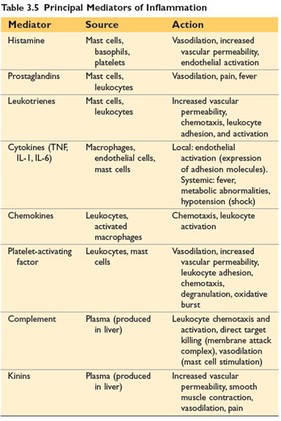
  - Cascade and Amplification: One mediator can stimulate the release of others, creating a cascade effect. For example, complement activation products can stimulate histamine release, and TNF can induce the production of IL-1 and chemokines by endothelial cells. This interplay allows for amplification or, in some cases, counteraction of the initial response.

Principal Mediators of Acute Inflammation
The most important mediators of acute inflammation include vasoactive amines, lipid products (prostaglandins and leukotrienes), cytokines (including chemokines), and products of complement activation.

Vasoactive Amines
These are among the first mediators released due to their storage as preformed molecules in cells.
- Histamine:
Abundantly found in mast cells (especially in connective tissue near blood vessels), blood basophils, and platelets.
Release Stimuli: Released by mast cell degranulation in response to:
  - Physical injury (trauma, cold, heat).
  - Binding of antibodies to mast cells (as in allergic reactions).
  - Complement products called anaphylatoxins (C3a and C5a).
  - Neuropeptides (e.g., substance P) and cytokines (IL-1, IL-8).
- Actions:
  - Causes dilation of arterioles and increases the permeability of venules, leading to interendothelial gaps. This is the principal mediator of the immediate transient phase of increased vascular permeability.
  - Can cause contraction of some smooth muscles, though leukotrienes are more potent in this regard (e.g., in asthma).
- Pharmacologic Inhibition: Antihistamine drugs, commonly used for allergies, are H1 receptor antagonists that block the receptor.

Serotonin (5-hydroxytryptamine):
Present in platelets and certain neuroendocrine cells (e.g., gastrointestinal tract). Found in mast cells in rodents, but not humans.
- Actions: Primarily a neurotransmitter. It is also a vasoconstrictor, though its importance in inflammation is unclear.

2.Arachidonic Acid (AA) Metabolites
Arachidonic acid (AA) metabolites are a crucial class of lipid mediators that stimulates vascular and cellular reactions during acute inflammation. They are also known as eicosanoids because they are derived from 20-carbon fatty acids.
  - Origin and Synthesis:
  - Arachidonic acid is a 20-carbon polyunsaturated fatty acid obtained from dietary sources or converted from linoleic acid.
  - Most cellular arachidonic acid is esterified and incorporated into membrane phospholipids.
  - When an injury occurs, mechanical, chemical, and physical stimuli or other mediators (like C5a) activate cellular phospholipases (mainly phospholipase A2), which release arachidonic acid from these membranes.
  - Once released, AA is rapidly converted into bioactive mediators by two primary enzyme classes:
  - Cyclooxygenases (COX): These enzymes generate prostaglandins.
  - Lipoxygenases: These enzymes produce leukotrienes and lipoxins.
  - Eicosanoids bind to G protein-coupled receptors on many cell types and can mediate virtually every step of inflammation.
  - Types of Arachidonic Acid Metabolites and Their Actions:
  - Prostaglandins (PGs):
  - Produced by mast cells, macrophages, endothelial cells, and many other cell types.
  - Generation: They are generated by the actions of two cyclooxygenases: COX-1 and COX-2.
  - COX-1: Constitutively expressed in most tissues, serving homeostatic functions (e.g., fluid and electrolyte balance in kidneys, gastric cytoprotection).
  - COX-2: Induced by inflammatory stimuli, generating prostaglandins involved specifically in inflammatory reactions.
  - Important Types and Actions:
  - PGD2 and PGE2: Major prostaglandins made by mast cells and widely distributed, respectively. They both cause vasodilation and increase the permeability of postcapillary venules, thus potentiating exudation and resultant edema. PGD2 also acts as a chemoattractant for neutrophils.
  - PGI2 (Prostacyclin): Produced by vascular endothelium. It is a vasodilator and a potent inhibitor of platelet aggregation, preventing thrombus formation on normal endothelial cells.
  - TXA2 (Thromboxane A2): Synthesized by platelets. It is a potent platelet-aggregating agent and vasoconstrictor, promoting thrombosis.
  - PGE2 also makes the skin hypersensitive to painful stimuli and causes fever during infections.
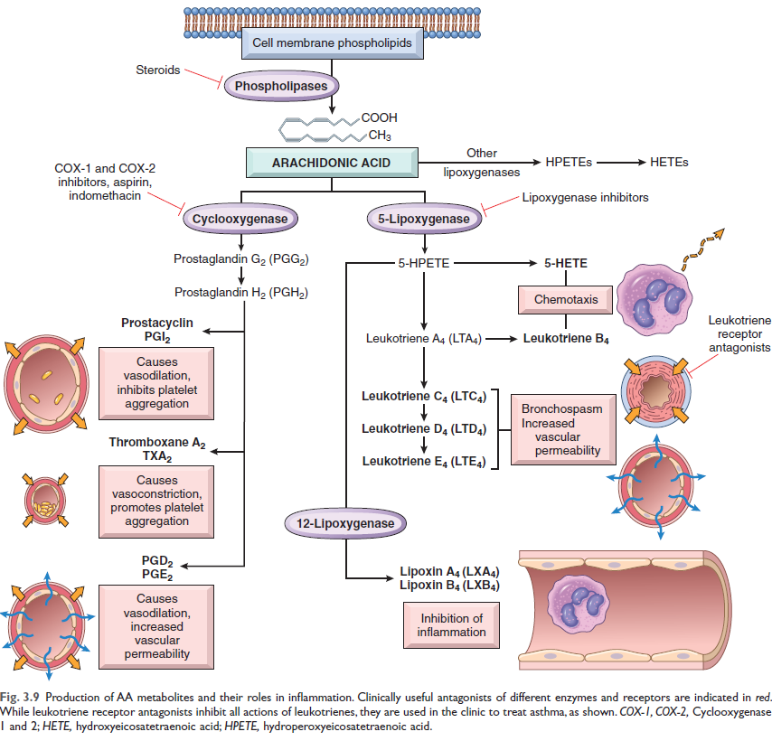
- Leukotrienes:
  - Produced in leukocytes and mast cells by the action of lipoxygenase.
  - Generation: The synthesis involves multiple steps, initially generating leukotriene A4 (LTA4), which then gives rise to LTB4 or LTC4.
  - Important Types and Actions:
  - LTB4: Produced by neutrophils and some macrophages. It is a potent chemotactic agent and activator of neutrophils, causing aggregation and adhesion to venular endothelium, generation of reactive oxygen species (ROS), and release of lysosomal enzymes.
  - Cysteinyl-containing leukotrienes (LTC4, LTD4, and LTE4): Produced mainly in mast cells. They cause intense vasoconstriction, bronchospasm (critical in asthma), and increased permeability of venules.
  - Lipoxins:
  - Generation: Also generated from arachidonic acid by the lipoxygenase pathway.
  - Actions: Unlike prostaglandins and leukotrienes, lipoxins suppress inflammation by inhibiting the recruitment of leukocytes. They specifically inhibit neutrophil chemotaxis and adhesion to endothelium. Their transcellular biosynthesis requires the interaction of two cell populations, particularly neutrophils and platelets.
  - Pharmacologic Inhibitors:
The understanding of eicosanoids has led to the development of numerous anti-inflammatory drugs.
- Cyclooxygenase Inhibitors:
  - Aspirin and other nonsteroidal anti-inflammatory drugs (NSAIDs) (e.g., ibuprofen): These inhibit both COX-1 and COX-2, thereby blocking prostaglandin synthesis and reducing pain and fever. Aspirin causes irreversible inactivation of cyclooxygenases.
  - Selective COX-2 Inhibitors: These are designed to primarily block COX-2, aiming to reduce inflammation without the gastric toxicities associated with COX-1 inhibition. However, Selective COX-2 inhibitors may increase the risk of cardiovascular events by impairing prostacyclin (PGI2) production while leaving platelet TXA2 production intact, tilting the balance towards thrombosis.
  - Lipoxygenase Inhibitors: Drugs like zileuton inhibit 5-lipoxygenase and are useful in treating asthma by reducing leukotriene production.
  - Corticosteroids: These are broad-spectrum anti-inflammatory agents that reduce the transcription of genes encoding COX-2, phospholipase A2, and proinflammatory cytokines (like IL-1 and TNF).
  - Leukotriene Receptor Antagonists: Drugs such as Montelukast block leukotriene receptors, preventing the actions of leukotrienes and are used in asthma treatment.

3. Cytokine and Chemokine System
Cytokines and chemokines are protein mediators that initiate, regulate, and terminate immune and inflammatory reactions.
Cytokines
Cytokines are proteins secreted by various cell types, including activated lymphocytes, macrophages, dendritic cells, endothelial cells, epithelial cells, and connective tissue cells, to mediate and regulate immune and inflammatory reactions.
  - Tumor Necrosis Factor (TNF) and Interleukin-1 (IL-1):
Activated macrophages and dendritic cells are the main producers of these cytokines. TNF is also produced by T lymphocytes and mast cells, and some epithelial cells produce IL-1.
- Inducers: Microbial products, foreign bodies, necrotic cells, and various other inflammatory stimuli trigger their secretion.
- Local Actions: Both TNF and IL-1 induce endothelial activation, a spectrum of changes in endothelial cells. These changes include:
  - Increased expression of endothelial adhesion molecules, such as E- and P-selectins and ligands for leukocyte integrins. This is crucial for leukocytes to adhere to the vessel wall.
  - Increased procoagulant activity of the endothelium.
- Leukocyte and Cell Activation: TNF enhances the responses of neutrophils and stimulates the microbicidal activity of macrophages. IL-1 activates fibroblasts to synthesize collagen and promotes the proliferation of synovial and other mesenchymal cells.
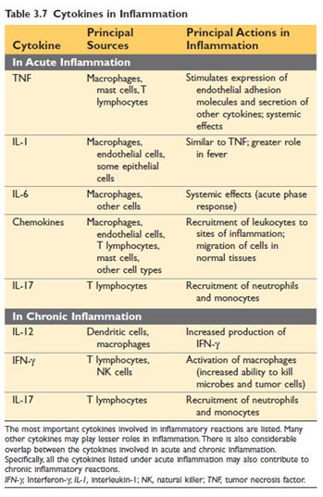
- Pathologic Effects: High levels can cause systemic inflammatory response syndrome (SIRS), including septic shock (hypotension, disseminated intravascular coagulation, metabolic disturbances). Sustained TNF production contributes to cachexia.
- Therapeutic Implications: TNF antagonists have proven highly effective in treating chronic inflammatory diseases such as rheumatoid arthritis, psoriasis, and some inflammatory bowel diseases.
  - Interleukin-6 (IL-6): Produced by macrophages and other cells, IL-6 is involved in both local and systemic inflammatory reactions. It contributes significantly to the systemic acute-phase response. IL-6 receptor antagonists are used in the treatment of rheumatoid arthritis.
  - Interleukin-17 (IL-17): Primarily secreted by T lymphocytes (TH17 cells), IL-17 induces the secretion of chemokines that recruit neutrophils and monocytes to inflammatory sites. A deficiency in effective TH17 responses can lead to increased susceptibility to fungal and bacterial infections, characterized by "cold abscesses" that lack classic acute inflammation signs. IL-17 antagonists are effective treatments for psoriasis and other inflammatory diseases.

Chemokines:
Chemokines are a family of small proteins (8–10 KD) that primarily function as chemoattractants for specific types of leukocytes. There are approximately 40 different chemokines and 20 known receptors for them. Leukocytes express multiple chemokine receptors, which often exhibit overlapping ligand specificities.
- Classification: Chemokines are categorized into four major groups based on the arrangement of their conserved cysteine (C) residues:
  - C-X-C Chemokines: These have one amino acid residue separating the first two of the four conserved cysteines. They primarily act on neutrophils. A typical example is IL-8 (CXCL8), secreted by activated macrophages, endothelial cells, and other cells. IL-8 activates and chemotaxes neutrophils, with limited activity on monocytes and eosinophils. Its production is primarily induced by microbial products and cytokines like IL-1 and TNF.
  - C-C Chemokines: The first two conserved cysteine residues are adjacent in this group. C-C chemokines mainly serve as chemoattractants for monocytes, eosinophils, basophils, and lymphocytes. Examples include monocyte chemoattractant protein (MCP-1, CCL2). While actions often overlap, eotaxin selectively recruits eosinophils.
  - C Chemokines: These lack the first and third of the four conserved cysteines and are relatively specific for lymphocytes (e.g., lymphotactin).
  - CX3C Chemokines: This class contains three amino acids between the first two cysteines. The only known member is fractalkine (CX3CL1), which exists in two forms: a cell surface-bound protein and a soluble form.
  - Mechanism of Action: Chemokines mediate their activities by binding to seven-transmembrane G protein–coupled receptors on the surface of leukocytes. Signals from these receptors induce cytoskeletal changes that drive cell migration.
  - Chemokines bind to proteoglycans and are displayed at high concentrations on the surface of endothelial cells and within the extracellular matrix, effectively creating a "chemical gradient" that guides leukocytes.
  - Functions:
    - Acute Inflammation: Most chemokines stimulate leukocyte attachment to the endothelium by increasing the affinity of integrins on leukocytes and serve as chemoattractants, guiding leukocytes to sites of infection or tissue damage. Their production is induced by microbes and other inflammatory stimuli. They are sometimes referred to as "inflammatory chemokines".
    - Tissue Architecture Maintenance: Some chemokines, known as "homeostatic chemokines," are constitutively produced by stromal cells in tissues. They are involved in organizing various cell types, such as T and B lymphocytes, within specific anatomic regions of tissues like the spleen and lymph nodes.

4. Complement System
The complement system is the body's defense mechanisms, comprising a collection of soluble proteins and their associated membrane receptors. Its primary function lies in host defense against microbes and its involvement in pathologic inflammatory reactions. This system operates within both innate and adaptive immunity to protect against microbial pathogens.

General Features
The complement system is made up of more than 20 proteins, some of which are numerically designated C1 through C9. These proteins circulate in the plasma in inactive forms. Upon activation, many of them transform into proteolytic enzymes that then degrade other complement proteins, initiating an enzymatic cascade that allows for significant amplification of the response.

Activation Pathways
The crucial step in complement activation is the proteolysis of C3, the most abundant complement component. This cleavage can occur via three distinct pathways:
- Classical Pathway: This pathway is triggered when the C1 protein binds to an antibody (IgM or IgG) that has already combined with an antigen.
- Alternative Pathway: This pathway can be activated directly by microbial surface molecules, such as endotoxin (LPS) and complex polysaccharides, even in the absence of antibodies.
- Lectin Pathway: In this pathway, plasma mannose-binding lectin binds to carbohydrates present on microbes, directly leading to the activation of C1.
All three activation pathways converge, leading to the formation of an enzyme known as the C3 convertase. This enzyme then cleaves C3 into two fragments: C3a, which is released, and C3b, which covalently attaches to the cell or molecule where complement is being activated. Subsequently, more C3b binds to these fragments to form C5 convertase, which then cleaves C5 into C5a (released) and C5b (attached to the cell surface). Finally, C5b binds to the late components (C6–C9), culminating in the formation of the membrane attack complex (MAC), which is composed of multiple C9 molecules. The enzymatic activity inherent in complement proteins enables massive amplification, with millions of C3b molecules potentially depositing on a microbe's surface within just 2 to 3 minutes.
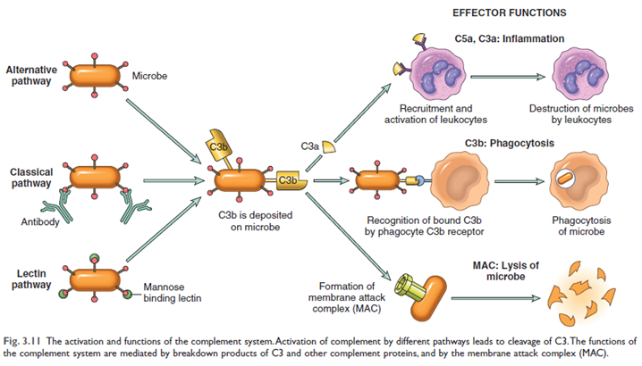

Principal Functions of the Complement System
The complement system performs three main functions essential for host defense and inflammation:
  - Inflammation:
- C5a, along with C4a and C3a (to a lesser extent), are cleavage products that stimulate histamine release from mast cells. This action consequently increases vascular permeability and causes vasodilation. These components are referred to as anaphylatoxins because their effects resemble those of mast cell mediators involved in anaphylaxis.
- C5a is also a potent chemotactic agent for neutrophils, monocytes, eosinophils, and basophils. Furthermore, C5a activates the lipoxygenase pathway of arachidonic acid metabolism in neutrophils and monocytes, leading to the release of additional inflammatory mediators.
  - Opsonization and Phagocytosis:
- C3b and its cleavage product iC3b (inactive C3b) act as opsonins when fixed to a microbial cell wall. Phagocytes, such as neutrophils and macrophages, possess cell surface receptors for these complement fragments, which promotes their phagocytosis.
  - Cell Lysis:
- The deposition of the MAC onto cells creates pores in the cell membrane, making the cells permeable to water and ions, ultimately leading to their osmotic death (lysis). This function is particularly crucial for killing microbes with thin cell walls, such as Neisseria bacteria (e.g. Neisseria meningococci and gonococci)

Regulation of Complement Activation
The complement system is tightly controlled by cell-associated and circulating regulatory proteins to prevent damage to healthy host tissues. Key regulatory proteins include:
- C1 inhibitor: This protein blocks the activation of C1, the initial protein of the classical complement pathway. An inherited deficiency of C1 inhibitor is the cause of hereditary angioedema.
- Decay accelerating factor (DAF) and CD59: DAF prevents the formation of C3 convertases, while CD59 inhibits the formation of the MAC. An acquired deficiency of the enzyme responsible for creating glycophosphatidyl (GPI) anchors leads to deficiencies in these regulators, resulting in excessive complement activation and lysis of red cells, a condition known as paroxysmal nocturnal hemoglobinuria (PNH).
- Other complement regulatory proteins: These proteins proteolytically cleave active complement components. For instance, Factor H, a plasma protein, acts as a cofactor for the proteolysis of the C3 convertase; its deficiency leads to excessive complement activation and is associated with kidney diseases and increased permeability of retinal vessels.
5. Other Important Mediators
  - Platelet-Activating Factor (PAF):
- Simplified by platelets, basophils, mast cells, neutrophils, macrophages, and endothelial cells.
- Actions: Causes platelet aggregation, vasoconstriction, and bronchoconstriction; at low concentrations. Also involved in leukocyte adhesion, chemotaxis, degranulation, and oxidative burst.
  - Products of Coagulation:
  - Inflammation and coagulation are linked. Protease-activated receptors (PARs) on leukocytes and platelets, activated by thrombin, suggest a role in inflammation, though its significance in directly stimulating inflammation is not fully established.
  - Kinins (e.g., Bradykinin):
- Derivation: Vasoactive peptides derived from plasma proteins called kininogens by kallikrein enzymes.
- Actions: Increases vascular permeability, causes contraction of smooth muscle, dilation of blood vessels, and pain when injected into the skin. Effects are similar to histamine but are short-lived due to inactivation by kininase.
  - Neuropeptides (e.g., Substance P, Neurokinin A):
- Secreted by sensory nerves and various leukocytes.
- Actions: Involved in pain signal transmission, blood pressure regulation, hormone secretion, and increasing vascular permeability.

Morphologic Patterns of Acute Inflammation
While general features (vasodilation, edema, leukocyte accumulation) are common, specific patterns can provide clues about the cause:
- Fibrinous Inflammation: Occurs with large vascular leaks or local procoagulant stimuli, allowing high-molecular-weight proteins like fibrinogen to pass out of blood and form fibrin deposits. Characteristic of inflammation in body cavity linings (meninges, pericardium, pleura). Fibrin can be dissolved or stimulate scar formation if not removed.
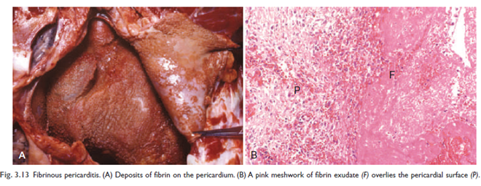
- Purulent (Suppurative) Inflammation and Abscess: Characterized by the production of pus, an exudate of neutrophils, liquefied necrotic cells, and edema fluid. Most often caused by pyogenic (pus-producing) bacteria like staphylococci. An abscess is a localized collection of pus buried in tissue, an organ, or a confined space, often walled off and eventually replaced by connective tissue.
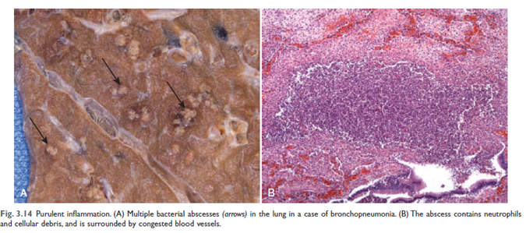
- Ulcers: A local defect or excavation of an organ or tissue surface due to the sloughing (shedding) of inflamed necrotic tissue. Ulceration occurs on or near a surface (e.g., mucosa of mouth, stomach, skin). Both acute (neutrophilic infiltration) and chronic (fibroblast proliferation, scarring, mononuclear cells) inflammation can coexist in ulcers.
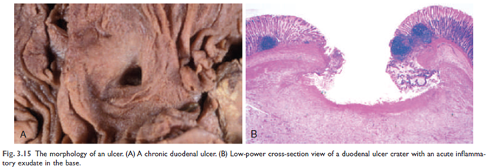
- Serous Inflammation: Characterized by exudation of cell-poor fluid into spaces created by injury or into body cavities. The fluid is not typically infected with destructive organisms and lacks large numbers of leukocytes. Examples include skin blisters from burns or viral infections.
VII. Outcomes of Acute Inflammation Acute inflammatory reactions typically have one of three outcomes:
- Complete Resolution: The ideal outcome, where the injurious agent is eliminated, mediators and inflammatory cells are cleared, injured cells are replaced, and the site is restored to normal function. This occurs with limited or short-lived injury and minimal tissue destruction.
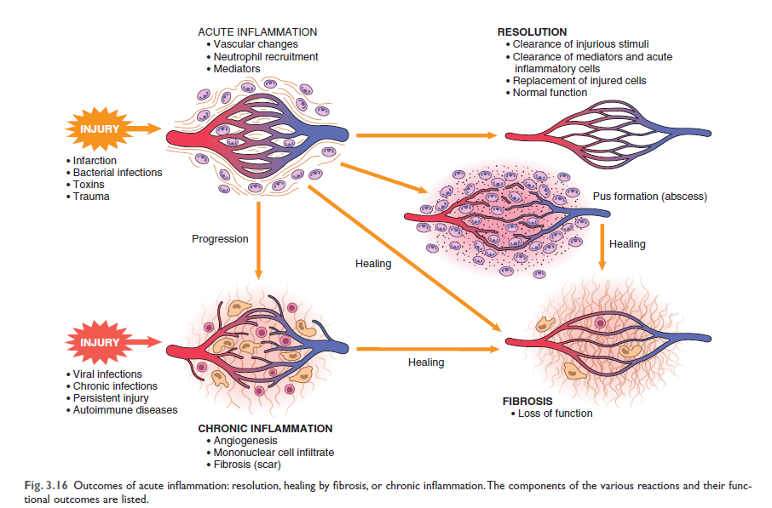
- Healing by Connective Tissue Replacement (Scarring or Fibrosis): Occurs after substantial tissue destruction, when regeneration is not possible, or when there is abundant fibrin exudation that cannot be cleared. Connective tissue grows into the damaged area, forming a fibrous scar.
- Progression to Chronic Inflammation: This happens if the acute inflammatory response cannot be resolved due to persistent injurious agents or interference with normal healing. Chronic inflammation is prolonged (weeks to months) and involves coexisting inflammation, tissue injury, and attempts at repair.

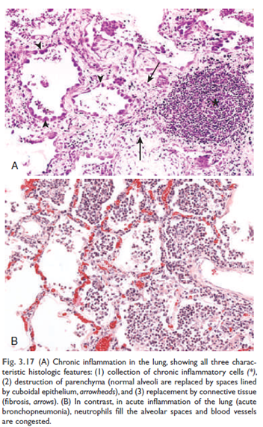
Chronic Inflammation
Chronic inflammation is a prolonged type of inflammatory response that occurs when the initial acute response fails to clear the stimulus, or it can arise insidiously without a preceding acute reaction. While inflammation is generally a protective response essential for survival, in some situations, it can become the cause of disease, with the damage it produces being its dominant feature. Chronic inflammation can lead to more severe and progressive tissue destruction compared to acute inflammation.

Causes of Chronic Inflammation
Chronic inflammation arises in several settings:
  - Persistent Infections: This is caused by microorganisms that are difficult for the body to eradicate, such as mycobacteria (e.g., in tuberculosis), certain viruses, fungi, and parasites. These pathogens often trigger a specific immune reaction known as delayed-type hypersensitivity. An unresolved acute bacterial infection, like a lung abscess, can also evolve into chronic inflammation.
  - Hypersensitivity Diseases: These are conditions where the immune system is excessively and inappropriately activated, leading to chronic inflammation and tissue damage.
    - Autoimmune diseases: The immune system misdirects its response against the body's own tissues (self-antigens), causing self-propagating immune reactions. Examples include rheumatoid arthritis and multiple sclerosis.
  - Prolonged Exposure to Potentially Toxic Agents: This can involve:
    - Exogenous agents: For example, long-term inhalation of particulate silica can cause silicosis, an inflammatory lung disease.
    - Endogenous agents: Atherosclerosis, a chronic inflammatory process affecting arterial walls, is thought to be partly induced by excessive production and tissue deposition of cholesterol and other lipids.
  - Association with Other Diseases: Chronic inflammation may play a role in the pathogenesis of diseases not traditionally considered inflammatory, such as type 2 diabetes, Alzheimer disease, and cancer.

Morphologic Features
In contrast to acute inflammation, which is characterized by vascular changes, edema, and predominantly neutrophilic infiltration, chronic inflammation is distinguished by the following:
- Infiltration with Mononuclear Cells: This includes a prominent presence of macrophages, lymphocytes, and plasma cells.
- Tissue Destruction: This damage is induced either by the persistent offending agent or by the inflammatory cells themselves.
- Attempts at Healing by Connective Tissue Replacement: This is accomplished through angiogenesis (proliferation of small blood vessels) and, notably, fibrosis (scarring). Angiogenesis and fibrosis are also components of wound healing and repair processes.

Cells and Mediators of Chronic Inflammation
Role of Macrophages
Macrophages are the dominant cells in most chronic inflammatory reactions. Circulating cells of this lineage are known as monocytes.
- Origin and Life Span: Monocytes originate from hematopoietic stem cells (HSCs) in the bone marrow, enter the blood, migrate into tissues, and differentiate into macrophages. Blood monocytes have a half-life of about 1 day, while tissue macrophages can live for several months or years. Many tissue-resident macrophages (e.g., Kupffer cells in the liver, alveolar macrophages in the lungs, microglia in the CNS) arise from embryonic precursors and are long-lived.
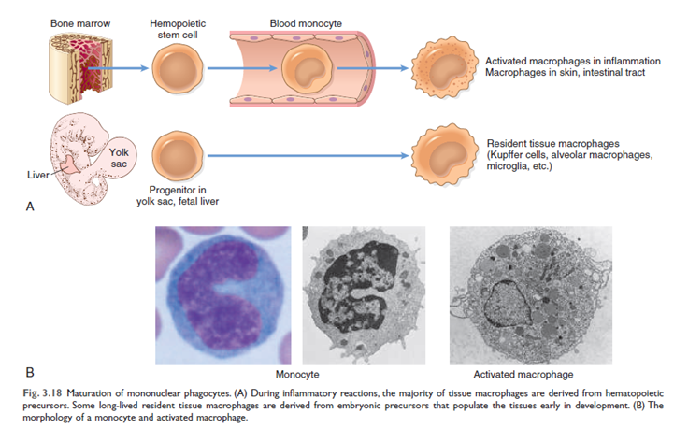
- Role in Acute Inflammation: Macrophages are slower responders than neutrophils but are capable of phagocytosis.
- Role in Chronic Inflammation and Repair: Macrophages are central to the development and persistence of chronic inflammation and the subsequent tissue repair.
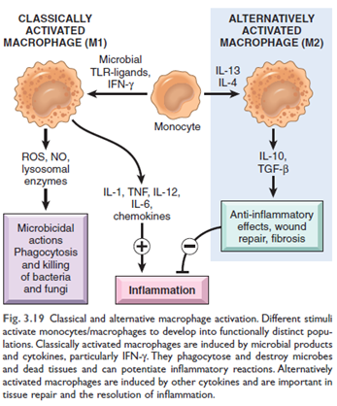
  - Macrophage Activation Pathways: Macrophages can be activated through two major pathways:
    - Classical Activation (M1): Induced by microbial products (e.g., endotoxin) and T cell–derived signals, particularly interferon-gamma (IFN-γ). M1 macrophages produce high levels of reactive oxygen species (ROS), nitric oxide (NO), and lysosomal enzymes, enhancing their ability to kill ingested organisms and secrete pro-inflammatory cytokines (e.g., TNF, IL-1, IL-12, IL-6, chemokines). They are important in host defense against microbes and perpetuate inflammatory reactions.
    - Alternative Activation (M2): Induced by cytokines such as IL-4 and IL-13, produced by T lymphocytes and other cells. M2 macrophages are not actively microbicidal. Their primary function is in tissue repair, where they secrete growth factors (e.g., TGF-β) that promote angiogenesis, activate fibroblasts, and stimulate collagen synthesis. They also have anti-inflammatory effects by producing IL-10 and TGF-β.
  - Secretion of Mediators: Activated macrophages secrete a wide array of inflammatory mediators, including cytokines (TNF, IL-1, chemokines) and eicosanoids, making them crucial for initiating and propagating inflammatory reactions.
  - Antigen Presentation and Lymphocyte Interaction: Macrophages play a vital role in adaptive immunity by displaying antigens to T lymphocytes and producing cytokines (e.g., IL-12) that stimulate T cell responses. This bidirectional interaction between macrophages and lymphocytes forms a feedback loop that fuels and sustains chronic inflammation.
  - Elimination of Damaging Agents and Orchestration of Repair: M1 macrophages clear microbes and necrotic tissue, while M2 macrophages produce growth factors that stimulate the proliferation of cells involved in repair, making them central cellular players in the healing process.
- Dual Role: Activated macrophages are critical for eliminating injurious agents and initiating repair, but their potent arsenal of mediators can also cause considerable tissue destruction when inappropriately or excessively activated, which is a hallmark of chronic inflammation.

Lymphocytes (T and B Cells)
Although leukocytes like neutrophils are prominent in acute inflammation, lymphocytes (T and B cells) are frequently present in chronic inflammation, and their activation tends to make the inflammation persistent and severe.
- Role in Chronic Inflammation: Lymphocytes amplify and propagate chronic inflammation, particularly in autoimmune diseases and chronic infections where they are activated by microbes and other environmental antigens. Strong chronic inflammatory reactions, such as granulomatous inflammation, are often dependent on lymphocyte responses.
- CD4+ T lymphocyte Subsets: CD4+ T lymphocytes promote inflammation by secreting specific cytokines:
  - TH1 cells: Produce IFN-γ, which activates macrophages via the classical pathway (M1 activation).
  - TH2 cells: Secrete IL-4, IL-5, and IL-13, which recruit and activate eosinophils and are responsible for the alternative pathway of macrophage activation (M2 activation). They are important in defense against helminthic parasites and in allergic inflammation.
  - TH17 cells: Secrete IL-17 and other cytokines that induce the secretion of chemokines, responsible for recruiting neutrophils and monocytes into the inflammatory site. TH1 and TH17 cells are involved in defense against many bacteria and viruses and in autoimmune diseases.
- Macrophage-Lymphocyte Interactions: These cells interact bidirectionally. Macrophages present antigens and provide co-stimulatory signals that activate T cells. Activated T lymphocytes, in turn, produce cytokines that recruit and activate more macrophages, reinforcing the cycle of inflammation.
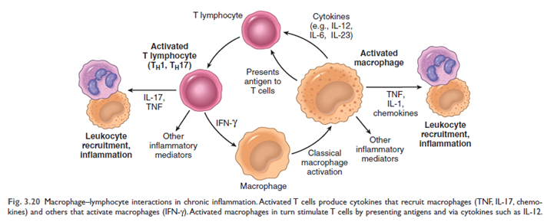
- B Lymphocytes and Plasma Cells: Activated B lymphocytes and antibody-producing plasma cells are often found at sites of chronic inflammation. They may produce antibodies against persistent foreign or self-antigens.
- Tertiary Lymphoid Organs: In some chronic inflammatory reactions, lymphocytes, antigen-presenting cells, and plasma cells cluster to form lymphoid structures resembling lymph node follicles, known as tertiary lymphoid organs. These are seen in conditions like rheumatoid arthritis and Hashimoto thyroiditis and may perpetuate the immune reaction.

Other Leukocytes
- Eosinophils: These cells are abundant in IgE-mediated immune reactions and parasitic infections. Their granules contain major basic protein, which is toxic to parasites but can also injure host epithelial cells, contributing to tissue damage in allergic reactions like asthma.
- Basophils: Circulating basophils share similarities with mast cells and can release inflammatory mediators, though mast cells generally play a more significant role in tissue inflammation.
- Mast Cells: Widely distributed in connective tissues, mast cells participate in both acute and chronic inflammation. In chronic reactions, they secrete a variety of cytokines that promote inflammation.
- Neutrophils: Although characteristic of acute inflammation, neutrophils can persist in large numbers in many forms of chronic inflammation (known as "acute on chronic" inflammation), driven by persistent microbes or cytokines from activated macrophages and T lymphocytes. For example, a neutrophilic exudate can persist for many months in chronic bacterial bone infection (osteomyelitis).

Key Mediators
While many mediators are involved, some are particularly relevant to chronic inflammation:
- Cytokines (TNF, IL-1, IL-6, Chemokines, IL-17): These are produced by macrophages, T lymphocytes, endothelial cells, and mast cells, and play crucial roles in leukocyte recruitment, activation, and systemic effects. Sustained production of TNF, for example, can contribute to cachexia.
- Transforming Growth Factor-beta (TGF-β): Produced by alternatively activated (M2) macrophages and other cells in granulation tissue, TGF-β is the most important cytokine for the synthesis and deposition of connective tissue proteins, playing a central role in fibrosis in organs like the lung, liver, and kidneys following chronic inflammation. It stimulates fibroblast migration and proliferation, increases collagen synthesis, and inhibits ECM degradation. TGF-β also has anti-inflammatory effects that help terminate inflammatory responses.

Granulomatous Inflammation
Granulomatous inflammation is a morphologically distinct pattern of chronic inflammation characterized by collections of activated macrophages (often resembling epithelial cells, called epithelioid cells), frequently accompanied by T lymphocytes, and sometimes associated with central necrosis. It is a cellular attempt to contain an offending agent that is difficult to eradicate.
  - Cellular Composition: The activated macrophages may fuse to form large multinucleate giant cells, such as Langhans giant cells, which are characteristic of granulomas. A collar of lymphocytes typically surrounds the aggregates of epithelioid macrophages.
  - Types of Granulomas:
  - Immune Granulomas: Caused by agents that induce a persistent T cell-mediated immune response when the provoking agent (e.g., certain microbes or self-antigens) cannot be easily eliminated. In these responses, macrophages activate T cells, which then produce cytokines like IL-2 and IFN-γ, further perpetuating macrophage activation.
  - Foreign Body Granulomas: Form in response to relatively inert foreign bodies (e.g., talc, sutures, fibers) that are too large for macrophages to phagocytose but are not immunogenic. Epithelioid cells and giant cells form around the foreign material, which can often be identified in the center of the granuloma.
  - Morphology and Necrosis: In standard tissue samples, epithelioid cells have pink, granular cytoplasm and unclear cell boundaries. Granulomas associated with certain infectious organisms, especially Mycobacterium tuberculosis, often contain a central zone of caseous necrosis (grossly appearing granular and cheesy; microscopically, amorphous, structureless, eosinophilic debris with loss of cellular details). Granulomas in conditions like Crohn disease, sarcoidosis, and foreign body reactions tend to be noncaseating (without necrotic centers).
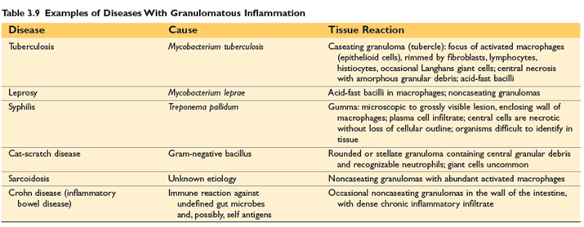
IX. Systemic Effects of Inflammation (Acute-Phase Response)
Localized inflammation can induce systemic reactions, primarily mediated by cytokines TNF, IL-1, and IL-6.
- Fever: Elevation of body temperature (1-4°C), caused by prostaglandins in the hypothalamus. Exogenous pyrogens (bacterial products) stimulate leukocytes to release endogenous pyrogens (IL-1, TNF), increasing cyclooxygenase activity and PGE2 production. NSAIDs reduce fever by inhibiting prostaglandin synthesis.
- Acute-Phase Proteins: Plasma proteins (e.g., C-reactive protein, fibrinogen, serum amyloid A) synthesized in the liver, increasing hundreds-fold. Act as opsonins, fix complement, or increase erythrocyte sedimentation rate (ESR). Prolonged production can lead to secondary amyloidosis.
- Leukocytosis: Increased leukocyte count (15,000-20,000 cells/mL, sometimes up to 100,000 cells/mL in "leukemoid reactions"). Due to accelerated release from bone marrow and increased production of precursors stimulated by CSFs. Neutrophilia (bacterial), lymphocytosis (viral), eosinophilia (allergies/parasites), or leukopenia (some infections).
- Septic Shock (Systemic Inflammatory Response Syndrome - SIRS): In "severe bacterial infections (sepsis)," high levels of TNF and IL-1 cause widespread abnormalities: "disseminated intravascular coagulation, hypotensive shock, and metabolic disturbances including insulin resistance and hyperglycemia." Can also occur in non-infectious conditions (burns, trauma).
- Other Manifestations: Increased heart rate/blood pressure, decreased sweating, rigors, chills, anorexia, somnolence, malaise.
Termination of Inflammation: Inflammation ceases when "the offending agent is eliminated" and is actively controlled by anti-inflammatory mechanisms to prevent excessive damage. After resolving, it initiates "the process of tissue repair."
X. Tissue Repair
The process by which damaged tissues are healed. The inflammatory response "sets into motion the process of repair."
A. Overview of Tissue Repair:
Two main types:
- Regeneration: "Replace the damaged components and essentially return to a normal state." Occurs by "proliferation of cells that survive the injury and retain the capacity to proliferate," and/or "maturation of tissue stem cells." Limited capacity in mammals.
- Connective Tissue Deposition (Scar Formation): If tissues "are incapable of complete restitution, or if the supporting structures... are severely damaged." Injured cells are replaced by "connective (fibrous) tissue," forming a scar. Provides structural stability but does not restore normal tissue. "Fibrosis" refers to extensive collagen deposition in organs.
Both processes involve cell proliferation and interactions with the extracellular matrix (ECM).
B. Cell and Tissue Regeneration:
Cell Proliferation: Driven by growth factors and critically dependent on ECM integrity. Cells that proliferate: remnants of injured tissue, vascular endothelial cells, fibroblasts.
  - Proliferative Capacity of Tissues:
    - Labile Tissues: Continuously dividing cells (e.g., skin and intestinal epithelia, hematopoietic cells); readily regenerate if stem cell pool is preserved.
    - Stable Tissues: Normally quiescent (G0), but can divide in response to injury (e.g., parenchyma of most solid organs like liver, kidney; endothelial cells, fibroblasts).
    - Permanent Tissues: Terminally differentiated, non-proliferative (e.g., neurons, cardiac muscle); injury results in irreversible scarring.
- Mechanisms: Proliferation of residual cells and differentiation of tissue stem cells.
- Liver Regeneration: Remarkable capacity due to proliferation of remaining hepatocytes (driven by IL-6, HGF) and repopulation from progenitor cells (e.g., oval cells in canals of Hering).
C. Repair by Scarring: "Replacement of the injured cells with connective tissue." Occurs if regeneration is incomplete or supporting structures are damaged.
Steps in Scar Formation:
- Hemostatic Plug: Platelet plug forms within minutes, stopping bleeding and providing scaffold.
- Inflammation: Acute and chronic inflammatory responses, recruiting neutrophils then monocytes/macrophages. Macrophages are central: M1 clear debris, M2 produce growth factors.
- Cell Proliferation (Granulation Tissue Formation): Epithelial cells migrate, endothelial cells and other vascular cells proliferate (angiogenesis), and fibroblasts proliferate and lay down collagen.
- Granulation Tissue: "Combination of proliferating fibroblasts, loose connective tissue, new blood vessels and scattered chronic inflammatory cells." Appears pink, soft, and granular.
- Angiogenesis: "Process of new blood vessel development from existing vessels." Driven by VEGF, FGFs, regulated by Notch signaling. New vessels are often leaky.
Remodeling: Connective tissue reorganized into a stable fibrous scar. Begins 2-3 weeks post-injury, can continue for months/years.
- Fibroblast Activation and ECM Deposition: Fibroblasts migrate and proliferate, some differentiate into myofibroblasts (contractile). They produce ECM proteins, mainly collagen. TGF-β is the "most important cytokine for the synthesis and deposition of connective tissue proteins."
- ECM Remodeling: Collagen degradation by matrix metalloproteinases (MMPs) and inhibition by tissue inhibitors of metalloproteinases (TIMPs) regulate scar size and nature. Scar strength increases due to collagen cross-linking and shift to Type I collagen.
D. Cutaneous Wound Healing:
- First Intention (Primary Union): Epithelial regeneration with minimal scarring (e.g., surgical incisions).
- Second Intention (Secondary Union): Larger wounds healing by "combination of regeneration and scarring," involving more extensive granulation tissue, inflammation, and wound contraction.
E. Factors That Impair Tissue Repair:
- Infection: Prolongs inflammation, increases injury.
- Diabetes: Compromises repair.
- Nutritional Status: Protein malnutrition, vitamin C deficiency inhibit collagen synthesis.
- Glucocorticoids (Steroids): Inhibit TGF-β, diminish fibrosis, leading to weak scars.
- Mechanical Factors: Pressure, torsion (can cause dehiscence – wound rupture).
- Poor Perfusion: Arteriosclerosis, obstructed venous drainage.
- Foreign Bodies: Impede healing.
- Type/Extent of Injury: Complete restoration only in proliferating tissues; extensive injury or injury to non-dividing cells leads to scarring.
- Location/Character of Tissue: E.g., exudates in tissue spaces may be resorbed, or undergo organization to fibrosis.
F. Clinical Examples of Abnormal Wound Healing and Scarring:
- Defects in Healing (Chronic Wounds):
  - Venous leg ulcers: Chronic venous hypertension, poor oxygen delivery.
  - Arterial ulcers: Atherosclerosis, ischemia.
  - Pressure sores: Prolonged compression, local ischemia.
  - Diabetic ulcers: Small vessel disease, neuropathy, metabolic abnormalities, secondary infections.
- Excessive Scarring:
  - Hypertrophic Scars: Raised scars with excessive collagen, tend to regress.
  - Keloids: Scar tissue growing "beyond the boundaries of the original wound and does not regress," genetically predisposed (e.g., African descent).
  - Exuberant Granulation (Proud Flesh): Excessive granulation tissue protruding above skin, blocking reepithelialization.
  - Contractures: Exaggerated wound contraction leading to deformities, common after burns.
- Fibrosis in Parenchymal Organs: "Excessive deposition of collagen and other ECM components in a tissue." Pathologic process induced by "persistent injurious stimuli" (chronic infections, immune reactions), often leading to "substantial organ dysfunction and even organ failure." Major cytokine is TGF-β. (e.g., liver cirrhosis, pulmonary fibrosis).
Inflammatory Cells
Inflammation is a fundamental protective response of vascularized tissues to infections and tissue damage, serving to bring host defense cells and molecules from the circulation to the sites where they are needed to eliminate harmful agents. This process involves the coordinated action of various cell types, each playing a specific role.
1. Overview
The types of cells involved in inflammation vary depending on the nature and duration of the response. Inflammation can be broadly categorized into two types: acute and chronic.
- Acute inflammation is the initial, rapid response, typically developing within minutes or hours and lasting a few days. It is characterized by the exudation of fluid and plasma proteins (edema) and the emigration of leukocytes, predominantly neutrophils.
- Chronic inflammation is a prolonged response lasting weeks or months, where inflammation, tissue injury, and attempts at repair coexist. It is characterized by infiltration with mononuclear cells (macrophages, lymphocytes, and plasma cells), tissue destruction, and attempts at healing through angiogenesis and fibrosis.
2. Leukocytes: The Circulating Defenders
Leukocytes, or white blood cells, are the primary cellular components of the inflammatory response. Most normally circulate in the blood but can be rapidly recruited to sites of infection or tissue damage.
2.1. Neutrophils (Polymorphonuclear Leukocytes)
Neutrophils are the main cellular infiltrate in most forms of acute inflammation, predominating during the first 6 to 24 hours. They are produced in the bone marrow and are rapidly recruited to sites of inflammation.
  - Characteristics and Life Span: Neutrophils are more numerous in the blood than other leukocytes and respond more rapidly to chemokines. They are characterized by their rapid, short-lived responses, primarily involving degranulation and enzymatic activity. After entering tissues, neutrophils are short-lived, undergoing apoptosis and disappearing within 24 to 48 hours.
  - Recruitment to Sites of Inflammation: As Discussed earlier.
- In Chronic Inflammation: Although characteristic of acute inflammation, neutrophils can persist in large numbers in some chronic inflammatory conditions, such as chronic bacterial infections (e.g., osteomyelitis) or lung damage from smoking, a pattern sometimes called "acute on chronic" inflammation.
3. Macrophages & Lymphocytes (as discussed in chronic inflammation)
4. Tissue-Resident Cells and Other Inflammatory Contributors
Beyond the circulating leukocytes, several tissue-resident cells and other components are crucial for initiating, regulating, and resolving inflammation.
4.1. Mast Cells
Mast cells are widely distributed in connective tissues, particularly adjacent to blood vessels, and participate in both acute and chronic inflammation.
- Histamine Release: Mast cells are the richest source of histamine. Histamine is one of the first mediators released during inflammation in response to physical injury, antibody binding (as in allergic reactions), or complement products (anaphylatoxins like C3a and C5a).
4.2. Endothelial Cells
The endothelial cells lining blood vessels are not merely passive conduits but actively participate in inflammation, particularly in vascular changes and leukocyte recruitment.
- Vascular Changes: In acute inflammation, endothelial cells undergo changes that increase blood flow and vascular permeability.
- Vasodilation: Induced by mediators like histamine, affecting arterioles and capillaries, leading to increased blood flow, which causes heat and redness.
- Increased Permeability: Endothelial cells retract, creating gaps that allow plasma proteins and leukocytes to leave the circulation. Direct endothelial injury (e.g., from burns or microbial toxins) can also cause sustained leakage.
- Angiogenesis: In tissue repair, endothelial cells proliferate and form new blood vessels, a process called angiogenesis.. It involves vasodilation, pericyte separation, basement membrane breakdown, endothelial cell migration and proliferation, remodeling into capillary tubes.
4.3. Fibroblasts and Myofibroblasts
These cells are crucial for tissue repair and scar formation, particularly in situations where regeneration is incomplete.
- Fibroblasts are the primary source of collagen, the major component of fibrous scars. Transforming growth factor-beta (TGF-β) is the most important cytokine for stimulating collagen synthesis and deposition.
- Myofibroblasts: Some fibroblasts differentiate into myofibroblasts, which contain smooth muscle actin and have increased contractile activity. These cells serve to close the wound by pulling its margins toward the center, contributing to wound contraction.
Fibrosis: Excessive deposition of collagen and other ECM components, often involving myofibroblasts as the main source of collagen, is termed fibrosis. This can lead to substantial organ dysfunction and is a hallmark of chronic inflammatory diseases in internal organs.
4.4. Platelets
Beyond their primary role in hemostasis, platelets contribute to inflammation.
  - Hemostatic Plug: Within minutes of injury, platelets form a hemostatic plug that stops bleeding and provides a skeleton for sensitive inflammatory cells.
  - Mediator Release: Platelets can release various inflammatory mediators. They contain serotonin, a vasoactive mediator. They can also elaborate platelet-activating factor (PAF), a phospholipid-derived mediator with multiple inflammatory effects, including vasoconstriction, vasodilation, increased vascular permeability, leukocyte adhesion, and degranulation.
Acute Vs Chronic Inflammation
- Onset and Duration
  - Acute inflammation is the initial, rapid response typically develops within minutes or hours and is of short duration, lasting for several hours to a few days.
  - Chronic inflammation is a response of prolonged duration, lasting weeks or months.
- Cellular Infiltrate
  - Acute inflammation is primarily characterized by the emigration of leukocytes, predominantly neutrophils (also called polymorphonuclear leukocytes
  - Chronic inflammation is characterized by the infiltration of mononuclear cells, including macrophages, lymphocytes, and plasma cells. In some prolonged cases, neutrophils can also remain present, a pattern referred to as "acute on chronic" inflammation.
- Vascular Changes and Fluid Exudation
  - Acute inflammation is characterized by the exudation of fluid and plasma proteins (edema).
  - Chronic inflammation typically associated with angiogenesis (proliferation of small blood vessels) as part of the healing attempts.
- Tissue Injury and Repair Attempts
  - In acute inflammation, tissue injury is usually mild and self-limited. Healing occurs by connective tissue replacement (scarring, or fibrosis).
  - In chronic inflammation, there is often severe and progressive tissue destruction. A specific morphologic pattern of chronic inflammation is granulomatous inflammation, characterized by collections of activated macrophages, often with T lymphocytes.
- Mediators Involved
  - Acute inflammation involves a rapid release of various mediators.
  - These include vasoactive amines like histamine (from mast cells, basophils, platelets) and serotonin (from platelets).
  - Arachidonic acid metabolites, such as prostaglandins (vasodilation, pain, fever) and leukotrienes (increased vascular permeability, chemotaxis, bronchospasm), are synthesized rapidly.
  - Key cytokines like TNF and IL-1 are produced by macrophages, endothelial cells, and mast cells.
  - Chemokines attract specific types of leukocytes.
  - The complement system generates products (C3a, C5a) that increase vascular permeability and are chemotactic.
  - Kinins, like bradykinin, also contribute to vascular permeability, smooth muscle contraction, and pain.
  - Chronic inflammation is sustained by cytokines produced by macrophages and lymphocytes, creating a bidirectional feedback loop.
- Local and Systemic Signs
  - Acute inflammation typically presents with prominent local and systemic signs. Local signs are the cardinal signs: redness, heat, swelling, pain, and loss of function. Systemic manifestations, collectively called the acute-phase response, include fever, production of acute-phase proteins and leukocytosis.
  - Chronic inflammation usually has less prominent local and systemic signs compared to acute inflammation. Chronic inflammatory reactions also underlie many common chronic diseases like rheumatoid arthritis and atherosclerosis.

